A hospital wants to determine whether there is any difference in the average Turn Around Time (TAT) of reports of the laboratories on their preferred list. They collected a random sample and recorded TAT for reports of 4 laboratories. TAT is defined as sample collected to report dispatch.

Analyze the data and determine whether there is any difference in average TAT among the different laboratories at 5% significance level.

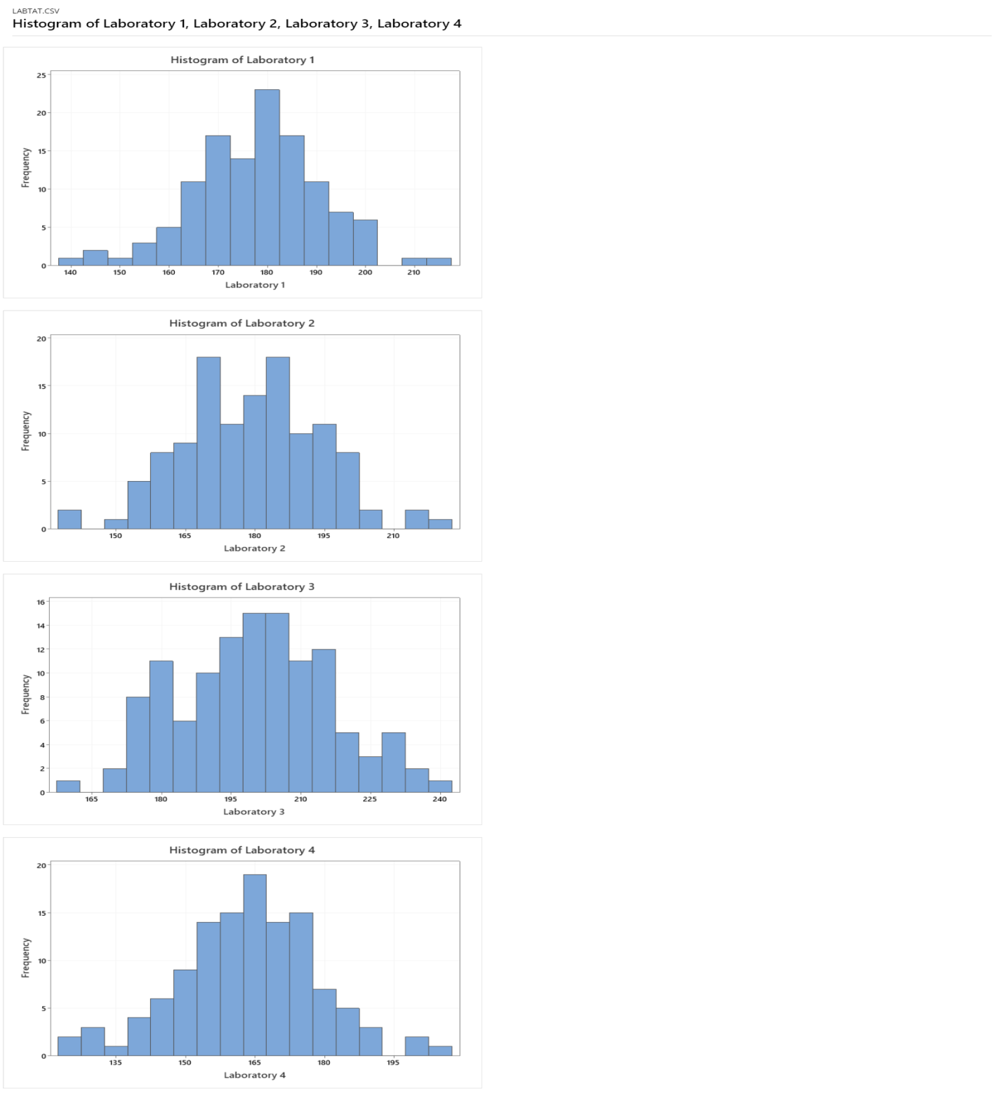

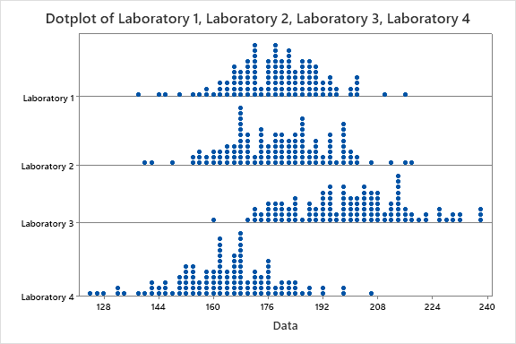

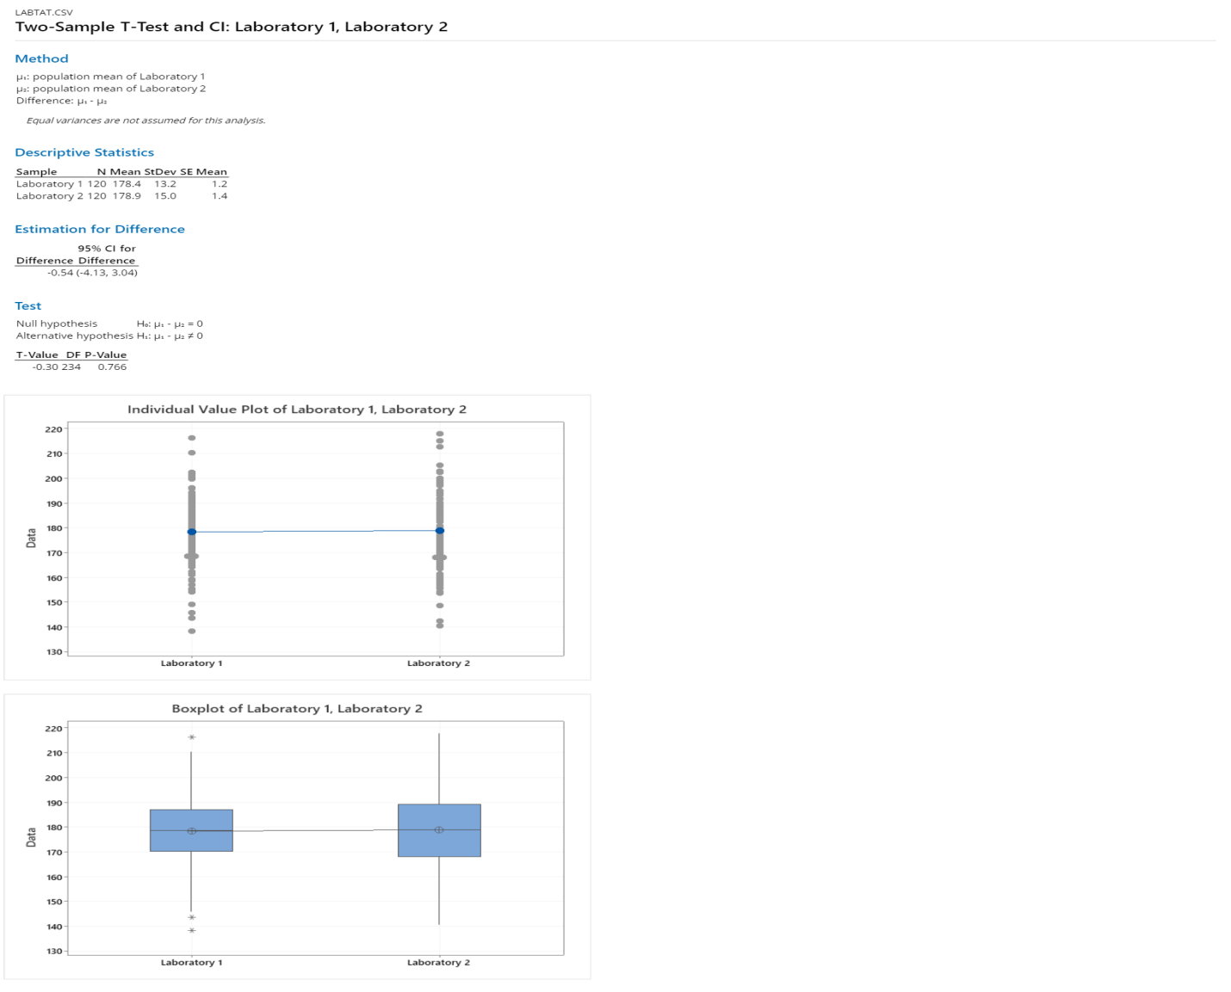

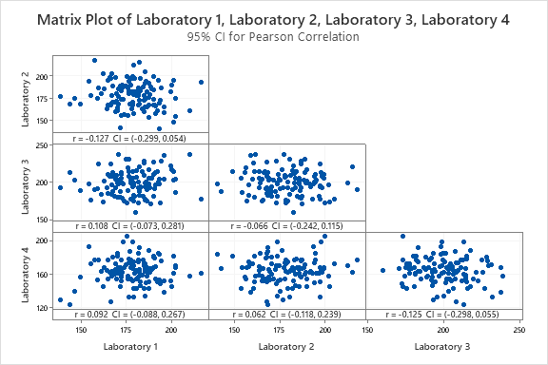

As there r value close to 0. There is no relation between the variables.

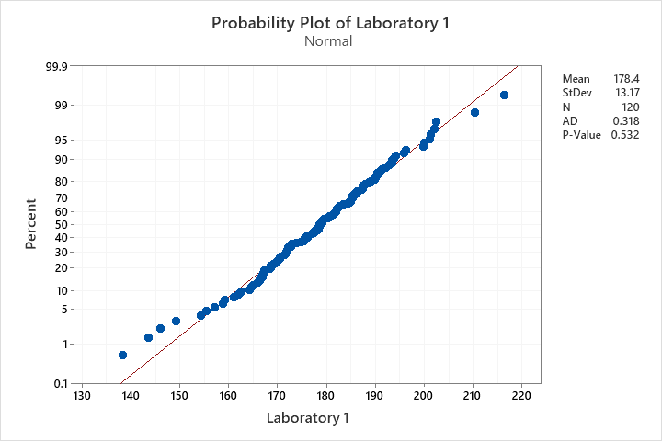

p-value is 0.532>0.05p high Ho fly accept null hypothesis hence data are normally distributed

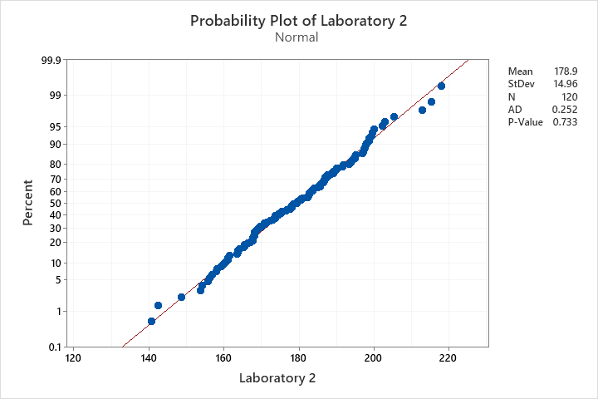

p-value is 0.733>0.05p high Ho fly accept null hypothesis hence data are normally distributed

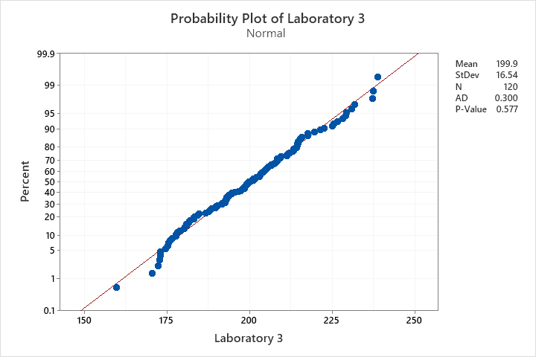

p-value is 0.577>0.05p high Ho fly accept null hypothesis hence data are normally distributed

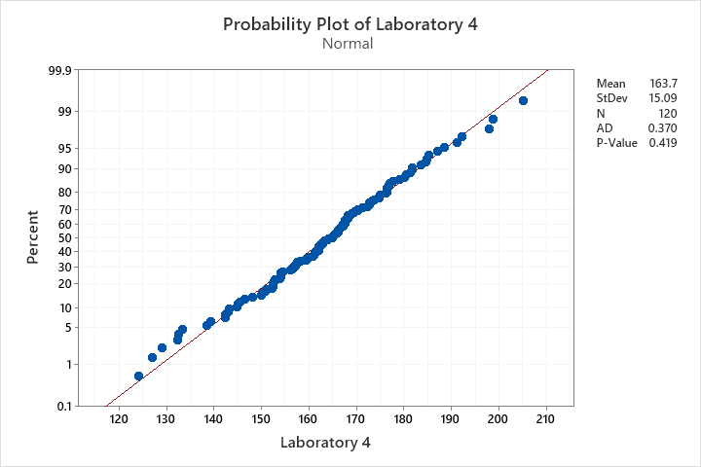

p-value is 0.419>0.05p high Ho fly accept null hypothesis hence data are normally distributed

**Anova one way test**

Ho= Average TAT for all the samples is same

Ha= Averages TAT for all the samples is not same

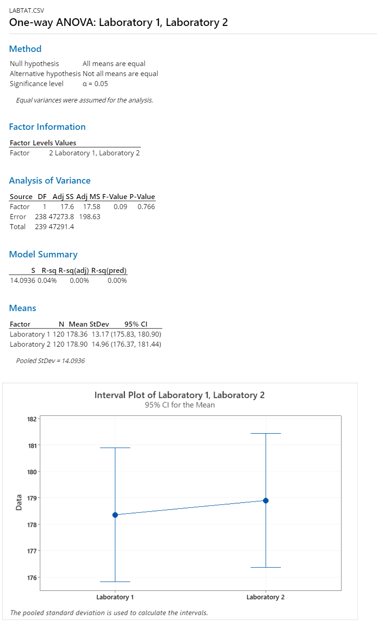

P-value >0.05. Accept the null hypothesis.